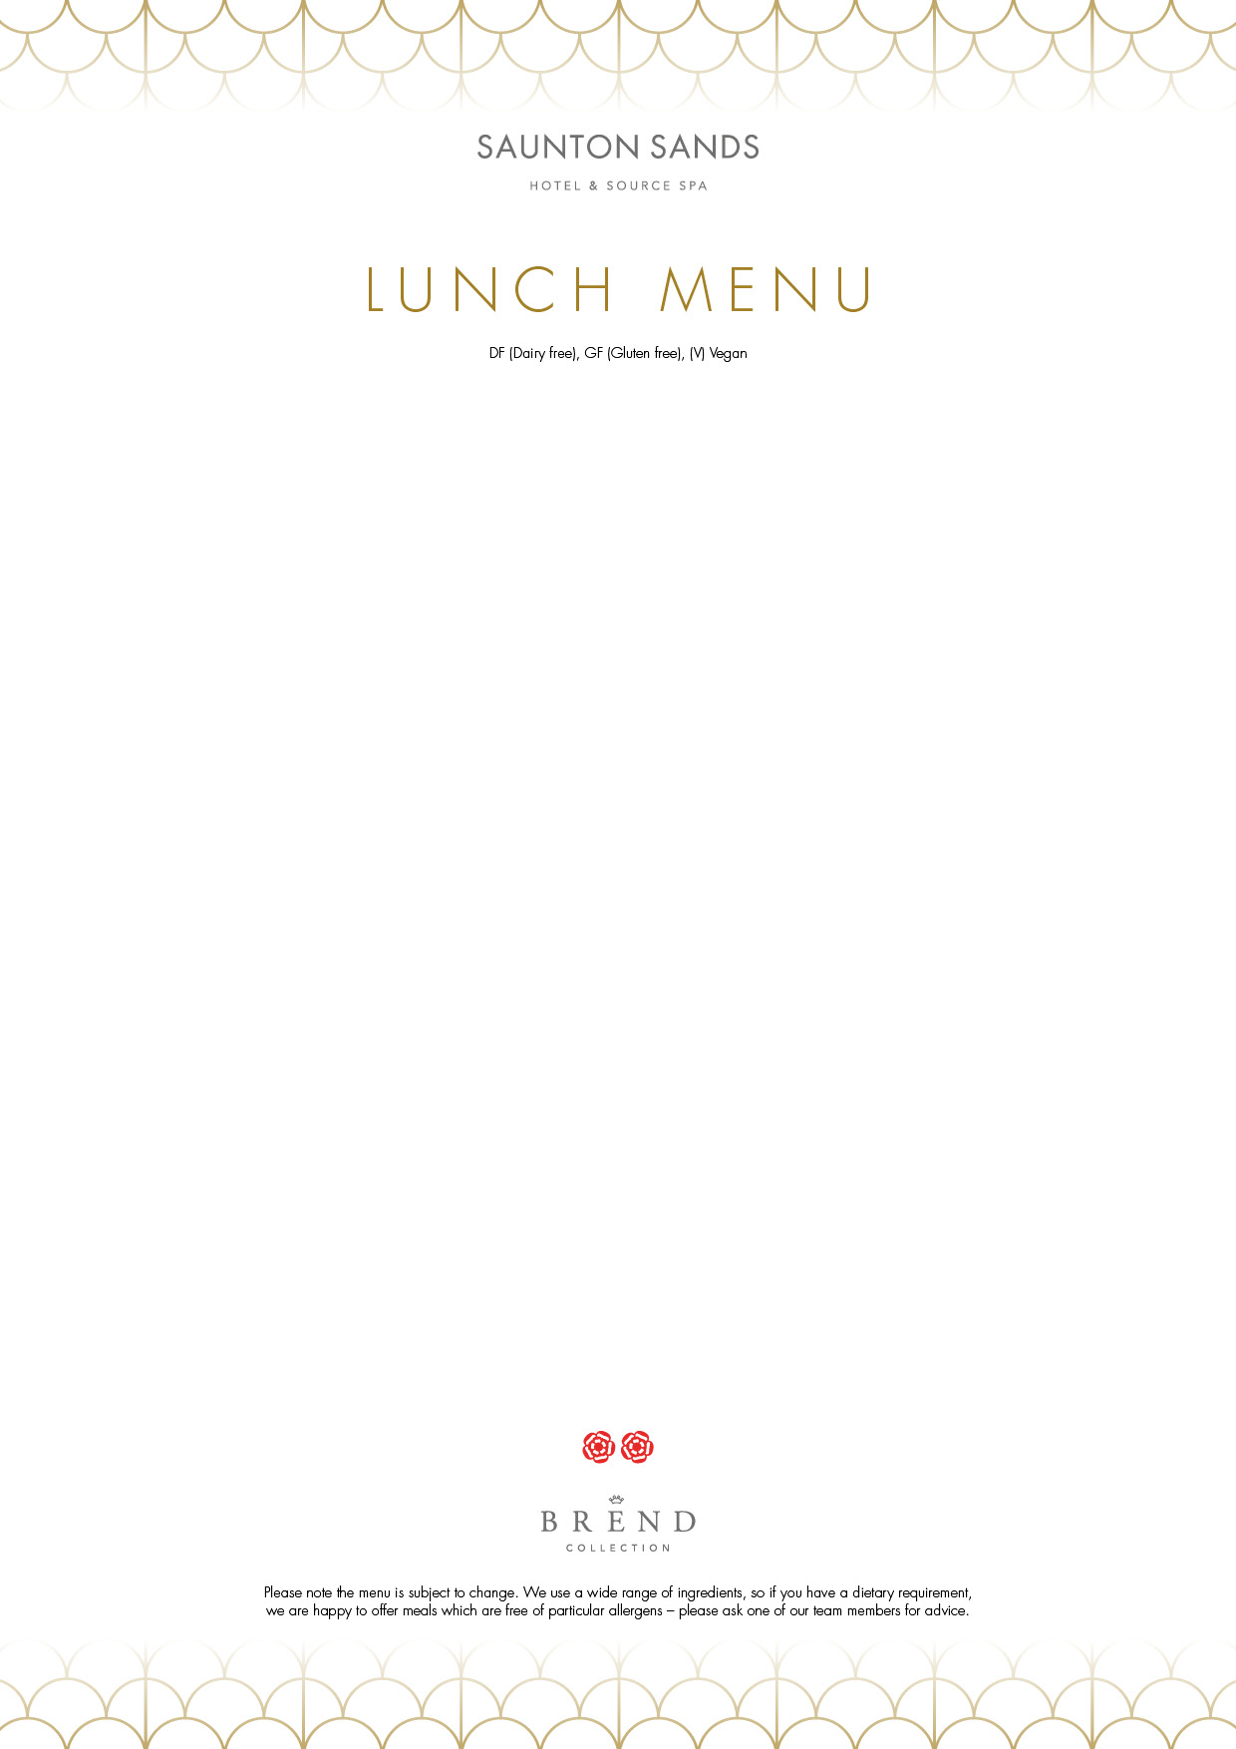
.

Golden Beetroot Soup
Saffron aioli, coconut flakes, coriander cress GF/DF (V)

Prawn Cocktail
Marie rose sauce, avocado mousse, baby gem lettuce, croutons GF

Ham Hock Terrine
Bread & butter pickles, mustard seed dressing, pea shoots DF/GF

*****
Pan Fried Potato Gnocchi
Sugar snaps, garden peas, mint, feta style cheese, lemon zest DF (V)

Pan Fried Sea Bream Fillet
Roasted potato gnocchi, sugar snaps, lemon grass velouté, pepper & coriander salsa
Grilled Chicken Supreme
Creamed potatoes, smoked pork belly, baby carrots, red wine jus GF

*****
Chocolate Brownie
Vanilla ice cream GF/DF (V)

Mango Parfait
Exotic diced fruit, basil snow GF

Southwest Cheese Selection
Biscuits, grapes and chutney

Build-your-own ice cream sundae
Yarde Farm ice cream
(ask your server for our sundae menu)

Three courses £37.50 per person
Two courses £30 per person

